Functional spECIFICATION
EF Model
Last updated Apr 1, 2011 by Simon.liu
[Project description - same as in Critter please.]
create a page in order to collect photos and students information from students for Ms EF competition.

1 Affected systems and web sites (including markets) 3
1.1 External systems and web sites 3
1.2 Internal systems 3
1.3 Web sites affected 3
1.4 Partner Affected 3
2 Purpose 3
3 Scope 3
4 Specific requirement 3
5 Tracking/Report 3

- Affected systems and web sites (including markets)
  - External systems and web sites
System name | Affected
Sales pages
Campaign page | X
Email English
Community
My Account
Checkout
Offline leads
Enrollment
If you think that part is relevant to you, please update the template, example for CR you can add Contact Us, for East Teacher tool under Internal systems, Wani etc…
  - Internal systems
System name | Affected
Deepblue
Omniture
Critter
Orpheus / UCP / Langlayer
Juno
Thor
Salesforce
Umbraco

  - Web sites affected
MKTs | ALL | BR | CN | DE | ES | FR | HK | IT | JP | KR | MX | TW | US | Others (pls specify)
“X” if affected |  |  | X
  - Partner Affected
Sales Partner | Partner Code  BR  CN  DE  ES  FR  HK  IT  JP  KR  MX  TW  US | Affected

- Purpose
EF launches new round of ads and seeks stars among our students. It is a marketing event among our students as well as a method to collect materials for future marketing campaigns
- Scope

This spec will include the content and design for the whole EF Model Campaign page.

4 Specific requirement

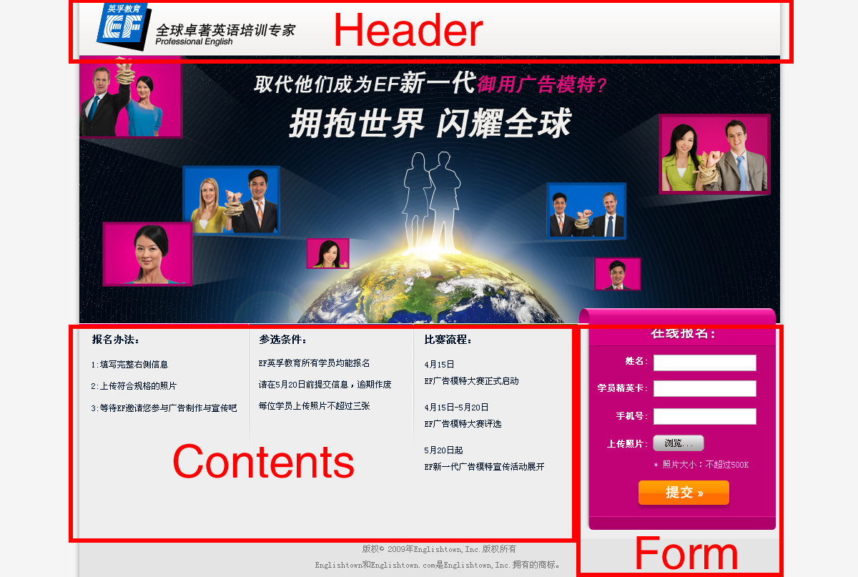

Main Requirement:

A. Page URL
http://www.ef.com.cn/model

Or
http://cn.englishtown.com/model

B.Html Head info
Meta title – 163508
Meta description – 163509
C.Header of Page:
- check attached logo image

D.Footer
Footer blurb ID: 163540

E.Contents
Only need Chinese version
Blurb ID | Contents | Comment
163510 | 报名方法：
163511 | Step 1:填写完整右侧信息  Step 2:上传符合规格的照片  Step 3:等待EF邀请您参与广告制作与宣传吧
163512 | 参选条件：
163513 | EF英孚教育所有学员均能报名  请在5月20日前提交信息，逾期作废  每位学员上传个人照片一张
163514 | 比赛流程：
163515 | 4月15日 EF广告模特大赛正式启动  4月15日-5月20日 EF广告模特大赛评选  5月20日起 EF新一代广告模特宣传活动展开

F.Form

User info Blurb ID | Contents | Tip text  blurb ID | contents
 |  | Gray watermark tip text in the input area
163517 | 姓名： | 163524 | 请输入中文
163518 | 学员精英卡： | 163525 | 您的8位卡号
163520 | 手机号： | 163526 | 您的手机号
163521 | 上传照片：
163522 | 照片大小：不超过500k

Rule of input contents
Rule | triggered  blurb ID | contents
1.if any field is blank | 163527 | 请输入内容
2.If user doesn’t Upload photo | 163528 | 请上传照片
3.Upload photo only support jpg,png,gif,bmp
(if we can change gif ,bmp.png automatically to jpg is better)
4.if image file size >500k,automaticly compressed to 500k
5.if input name is not Chinese | 163524 | 请输入中文
6.inputed card number must can be found in our student’s card number database | 163529 | 请输入您的正确精英卡号
7.mobile number must be 11 numbers | 163530 | 请输入正确手机号
8.photo name should automatically named as studends card number. For example:sh212345.jpg

G. Data store:
Considering commonality of data store ,if we have similar project later ,we can store data in the same place.

H.data transfer:
Send user info (excel format ) monthly ,send to Alyson.Ahearn@ef.com, Emily.Linqianming@ef.com
And Provide zipped photo file download address to Alyson.Ahearn@ef.com, Emily.Linqianming@ef.com at same time

I. pop up thank you info
Blurb id: 163541

QA point:
- form can collect user info
- Working under IE6,IE8,firefox 3+

Tracking/Report
All links need to be able to be tracked by Omniture such as click map in Omniture should be able to show how many people click on the text links, Videos, flash. Omniture page names are provided

Insert Omniture code for this page:
Omniture Name: SalesPages:Smart:EEmodel

